Assignment-4

Assignment 4: Write SQL statements to CREATE a new database and tables that reflect the library schema you designed earlier. Use ALTER statements to modify the table structures and DROP statements to remove a redundant table.

Consider the Books table:
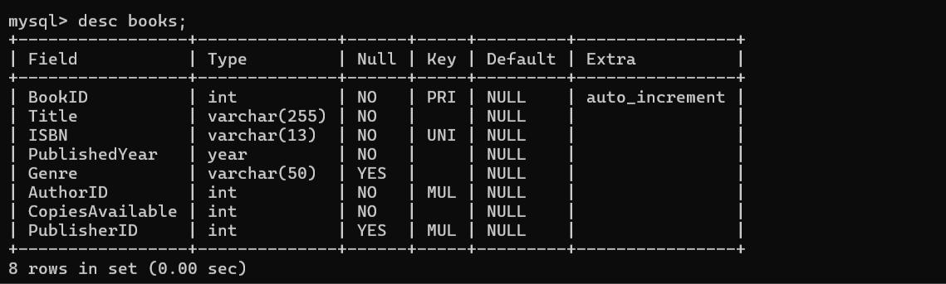

Modify the Books Table Structure Using ALTER:

1. Rename Column Genre to Category
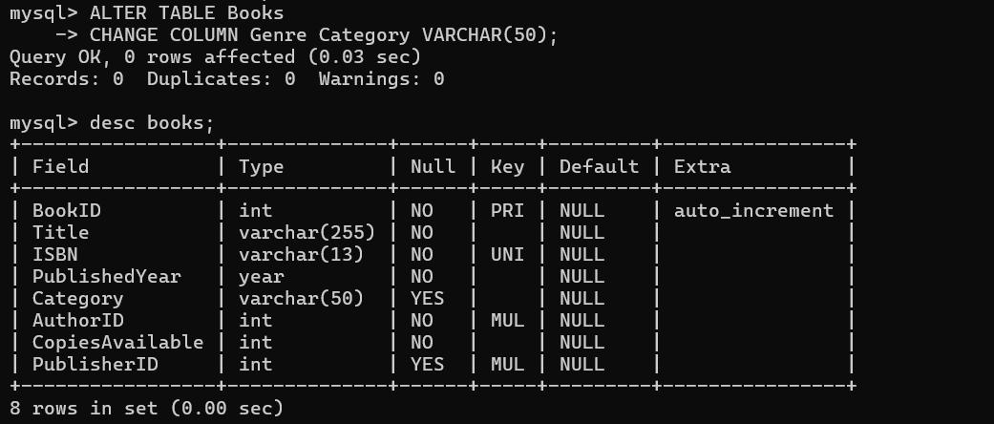

2. Add a New Column for LastUpdated with Default Value
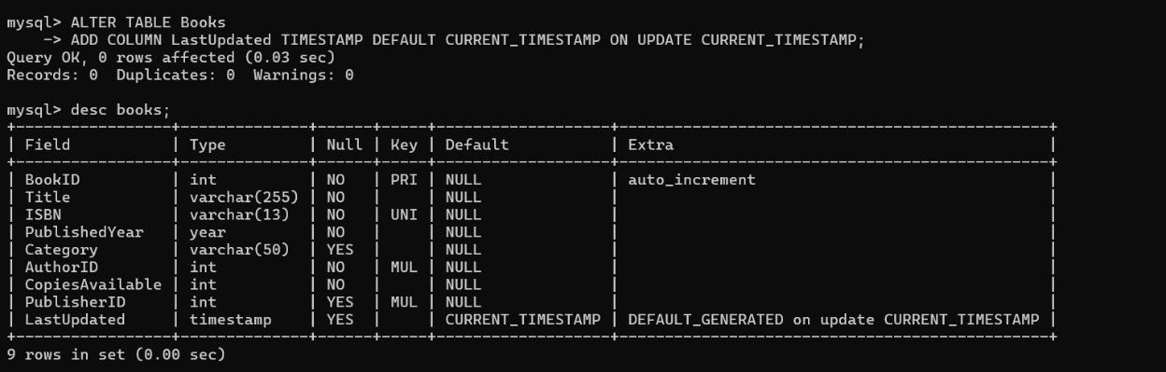

Drop a Publisher Table:
